SPENCER STREET SURGERY
NEW PATIENT REGISTRATION PACK
OVER 16'S
CHECKLIST FOR REGISTERING NEW PATIENTS - OFFICE USE ONLY
Named GP (please inform patient also)
 |  | YES | NO
Has the patient been informed of the opt out organ donation?
Has the patient opted into online services?
Has the patient consented to being contacted via email?
Has the patient consented to being contacted via texting?
Has the catchment area been checked?
Are all fields in the purple form completed?
Has the alcohol questionnaire been completed?
If opted out of summary care records, has a form been given?
Have you offered a new patient health check?
2 forms of ID been seen and copied
(photo ID/ copy of address)
Has the patient been offered a practice leaflet?
Staff signature: |  | Date:

- Please complete this confidential questionnaire
(One for each member of the family being registered with the practice)
- Please complete all and tick boxes as appropriate

Full name: | Home number:
Mr/ Mrs/Miss/Ms/Other: | Work number:
House name/number: | Mobile number:
Street: | Email address:
City: | Next of kin:
County: | Next of kin contact number:
Postcode: | Town and Country of Birth:
Previous/ Mother’s surname if different: | Date of birth:
Marital status: | Gender:
NHS number: (if known) | Other residents of your home:
Occupation: | If applicable, date you first came to live in Britain:
Previous address: | Previous GP name, address and contact number:
If returning from the armed forces:  Your service or personnel number and enlistment date: | Are you a military veteran?  Yes No  RECEPTION ADD CODE IF VETERAN

Your height:  Feet/inches:  Cm: | Your weight:  Stones/lbs:  Kg:
Your religion (please tick):  C of E  Catholic  Other Christian (please state)  Buddhist  Hindu  Muslim  Sikh  Jewish  Jehovah’s Witness  No religion  Other religion (please state) | Your ethnic origin (please tick):  White (UK)  White (Irish)  White (Other)  Caribbean  African  Asian  Other mixed background  Indian/ Brit Indian  Pakistani/ Brit Pakistani  Bangladeshi/ Brit Bangladeshi  Other Asian background  Other black background  Chinese  Other  Ethnic category not stated
Languages spoken/ understood  (please tick)  English  Hindi  Gujurati  Urdu  Bengali  Punjabi  Polish  Ukrainian  French  German  Spanish  Other (please state | Smoking status:  Are you a current smoker?  Yes No  Have you ever been a smoker?  Yes No  If so, how many cigarettes/cigars/tobacco do you smoke in a week?  If you are a smoker and want to stop, please see Reception for smoking cessation details
Alcohol status:  Do you drink alcohol?  Yes No  If so, please fill in the alcohol questionnaire later on in this registration pack | Exercise:  How often do you exercise?  (number of times per week)  Type of exercise:
Please see the next page for your medical background:

Have you received medical care outside the NHS in the past 5 years?
(e.g. treatment abroad, in the armed forces, prison medical services)

What illnesses have you had and when?

What operations have you had and when?

Do you have any medical problems at present?

Please list any tablets, medicines or other treatments you are currently taking:
(Inc. dose and frequency)

Do you have a preferred pharmacy where you would like your prescriptions to be sent?
If so please state below:

Are there any serious diseases that affect your parents, brothers or sisters?
(please tick all that apply)

Diabetes
Heart attack
Heart attack under the age of 60
Bowel cancer
Breast cancer
Hypertension
Asthma
Stroke
Thyroid disorder

Any other important family illnesses?

Specific needs: | (please detail any specific needs below so the practice can ensure they are identified and accommodated)
Any sensory impairment you have:
(speech, hearing, sight)
Do you have an assistance dog?
Please state any physical disabilities you have:
Please state any mental disabilities you have:

Please state any requirements you have to be able to access the practice:
Please state any religious or cultural needs:
Do you require the help of a translator:
Please state any nutritional requirements you have:
Please state any allergies and sensitivities you have:

If you are a carer, please state name/address/ phone number of the person you care for: | Person cared for contact details:
If you have a carer, please state their name/address/phone number and sign below if you wish us to disclose information about your heath to your carer: | Carer contact details
Signed: | Date:

Do you have a ‘Living Will’?  (a statement explaining what medical treatment you would not want in the future: | Yes No  If yes, please could you bring a copy for your records
Have you nominated someone to speak on your behalf?  (e.g. a person who has a Power of Attorney) | If yes, please state their name/ address/phone number below:

Women only
Date of last mammogram: | Method of contraception used:

Summary Care records:
The NHS is changing the way your health information is stored and managed. The NHS Summary Care record is an electronic record of important information about your health. It will be available to health care staff providing your NHS care. If you required more information please see Reception.

Are you happy to have a summary care record? | Yes | No | More time required to decide:

Organ donation – is now an opt out system – if you wish to opt out please visit https://www.organdonation.nhs.uk

So that we can ensure appropriate continuing care, have you ever had treatment or been told you have any of the following | Hepatitis YES NO  If yes, please state type of hepatitis ……………………………………………  HIV YES NO  Sickle cell disease YES NO  (If you do not wish to disclose any of the above, please discuss with your GP at your next appointment)

If you are registering a child and have a record of their immunisations- please bring this for us to photocopy. If you have no record of this or are an adult please fill in as much information into the table below.

Immunisation | Date given

Thank you for completing this form.

Please sign below to confirm all details on this form are correct to the best of your knowledge:

Patient signature:……………………………………………………

Date:…………………………………………………………………..

For more information about the services we offer, please see our website:

www.spencerstreetsurgery.co.uk

Please see the rest of the pack for the alcohol questionnaire, information on online services and summary care records.

Alcohol Use Questionnaire

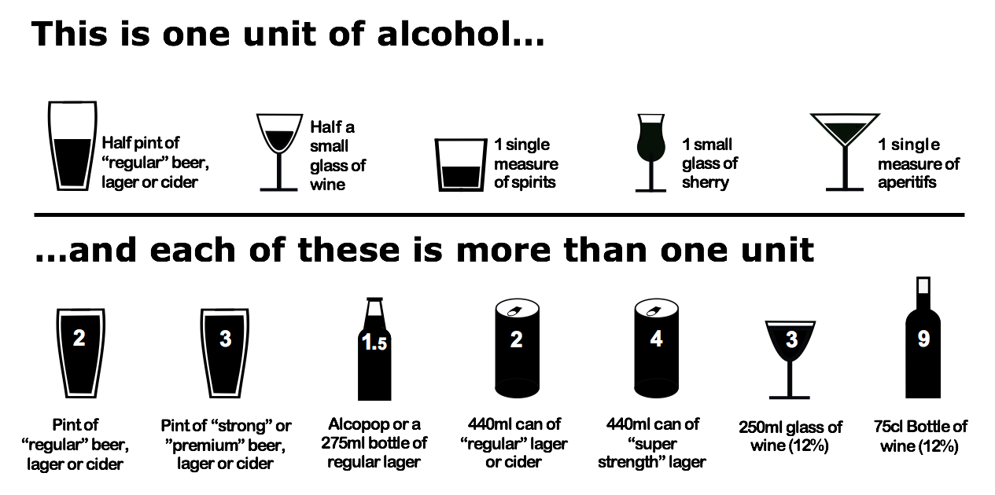

Questions | 0 | 1 | 2 | 3 | 4 | Your score
How often do you have a drink containing alcohol? | Never | Monthly or less | 2-4 times per month | 2-3 times per week | 4+ times per week
How many units of alcohol do you drink on a typical day when you are drinking? | 1-2 | 3-4 | 5-6 | 7-9 | 10+
How often have you had 5 or more units if female, or 8 or more if male, on a single occasion in the last year? | Never | Less than monthly | Monthly | Weekly | Daily or almost daily

Scoring:
A total of 5+ indicates increasing or higher risk drinking.
An overall total score of 5 or above is AUDIT-C positive.

Your score:……………………………………………………………

If you have scored more than 5, please complete the questionnaire overleaf.

Remaining AUDIT questions

Questions | 0 | 1 | 2 | 3 | 4 | Your score
How often during the last year have you found that you were not able to stop drinking once you started?
How often during the last year have you failed to do what was normally expected from you because of your drinking?
How often during the last year have you needed an alcoholic drink in the morning to get yourself going after a heavy drinking session?
How often during the last year have you had a feeling of guilt/remorse after drinking?
How often during the last year have you been unable to remember what happened the night before because you had been drinking?
Have you or somebody else been injured as a result of your drinking?
Has a relative or friend, doctor or other health worker been concerned about your drinking or suggested that you cut down?

Scoring:
0-7 lower risk
8-15 increasing risk
16-19 higher risk
20+ possible dependence

Total score for this page:………………………………………………………

Opting in and out of communication from Spencer Street Surgery

Name | D.O.B

Texting correspondence: please tick which option you would prefer.

Spencer Street Surgery provides a texting service.

We use this service to contact you about some of the following:
• Appointment Reminders
• Health Campaign Messages (no more than once/month)
• Messages relating to your own general health and care

There is no charge to receive messages, but replies are charged at your operator’s rate.

Opt IN | Opt OUT

Signature of patient:…………………………………………………………………………..

Date:……………………………………………………………………………………………

Email correspondence: please tick which option you would prefer.

Opt IN | Opt OUT

Signature of patient:…………………………………………………………………………..

Date:……………………………………………………………………………………………

Online Access

As part of our registration process we automatically set you up for online services. We then email/print you your login details and you can use the service most suitable for you.

We will need to verify your ID in order for this to be processed.

If you would NOT like to be signed up for this service please sign and date below.

Name:…………………………………………………………………………………………
Date:…………………………………………………………………………………………..

Information for carer’s to have access to

A carer is someone who gives unpaid care to a relative or friend with health problems, or a disability, who would be otherwise unable to manage at home without their help.

Information of carer

Title
Family Name
Given Name
Gender
NHS number
Date of birth
House name/number
House Street
Locality
Town/city
County
Postcode
Home Telephone
Work Telephone
Mobile Telephone
Primary email address
Secondary email address

This information will be then added to your records.

